INTERNATIONAL USER PROCEDURE
\\\\\\\
- Log into online banking using username and temporary password.
- Click Send Code to initiate email.

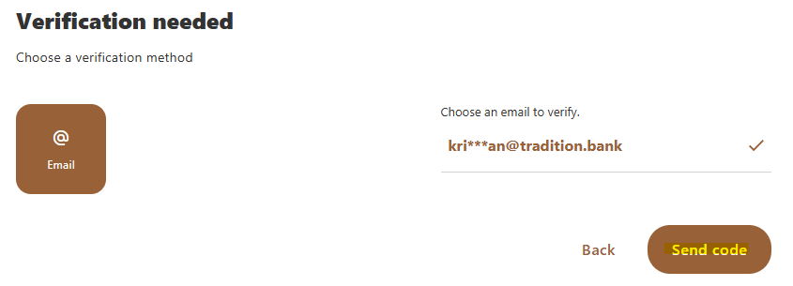
- Input verification code from email and click Verify.
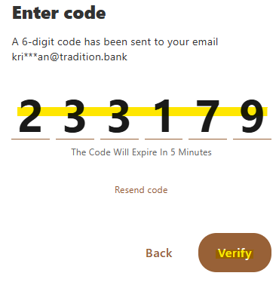
- Create new password.
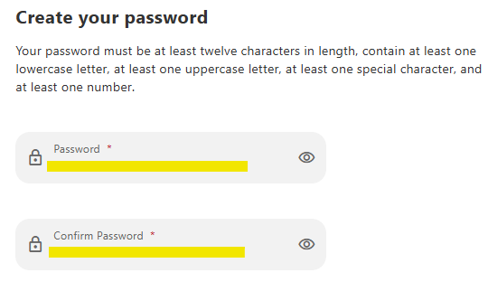

- Input Date of Birth and Mobile Phone.
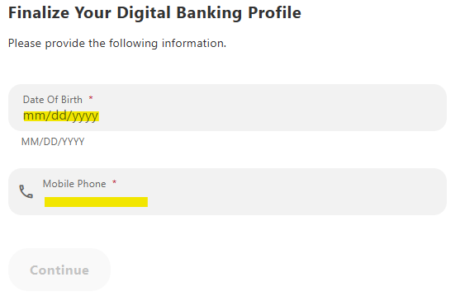
- Download a two-factor authentication app of your choice. DUO is being used in this example. Other examples include Google Authenticator, Microsoft Authenticator, and 2FAS.
- Within DUO App, click Add.


- Click Use QR code.
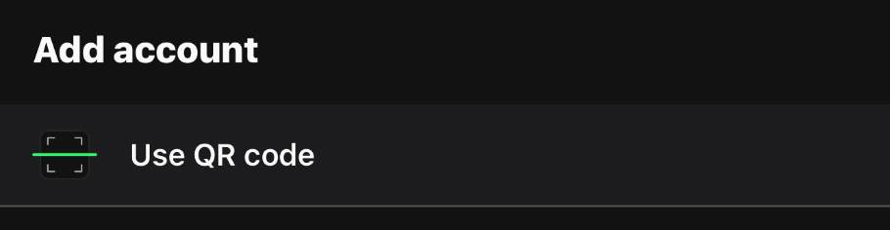
- Scan QR Code on online banking screen.
- Follow prompts on app.
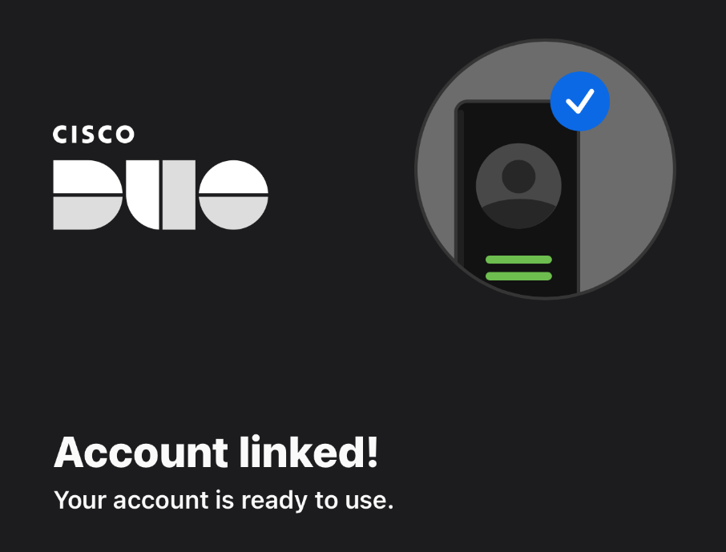
- Input code from DUO App on online banking screen.
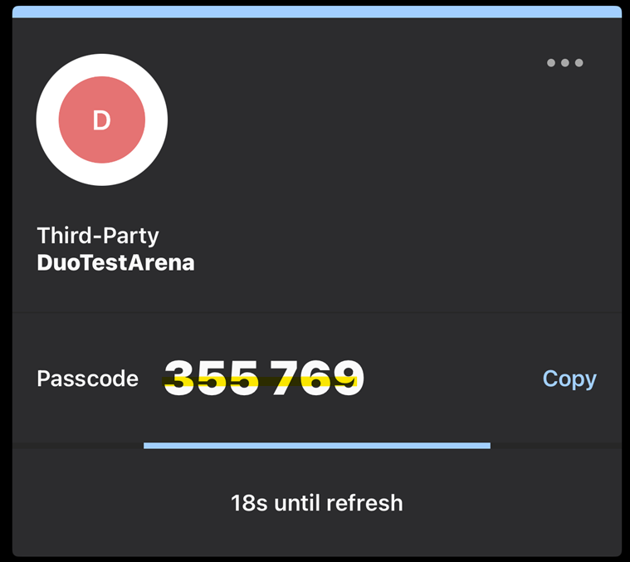
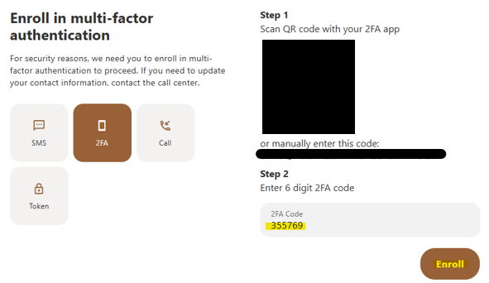
- Prompts will appear to use the two-factor authentication with the next log in.

